Projektbeschreibung:

Projekttitel:
RoboCupSoccer2D

Projektteilnehmer:

<TU Hao, if18b181@technikum-wien.at>
< Alejandro Rodriguez, if18b059@technikum-wien.at >
<Dharmik Chaklasiya, if19b189@technikum-wien.at >

Projektkoordination:
DI Dr. Felix Mödritscher
Kontaktperson:
DI Dr. Felix Mödritscher

Kurzfassung / Abstract:

The RoboCup simulator league is based on the RoboCup simulator called the
soccer server [Noda97RoboCup97], a physical soccer simulation system. All games are visualised by displaying the field of the simulator by the soccer monitor on a computer screen. The soccer server is written to support competition among multiple virtual soccer players in an uncertain multi-agent environment, with real-time demands as well as semi-structured conditions.

Ausführliche Projektbeschreibung:

Before starting the project, you need to learn to understand the linux operating system. Because The project's server is based on Linux.

First need to download the server, And compile on linux system.
We use ubuntu version of Linux, and server rcssserver-16.0.0.
The server is written with c++ , The server is a system that enables various teams to compete in a game of soccer. The only requirement is that the tools used to develop a team support client-server communication via UDP/IP.
The server receives instructions from different objects, The object and class in the server controls the entire simulated behavior.

UML diagram of the objects in the simulation:

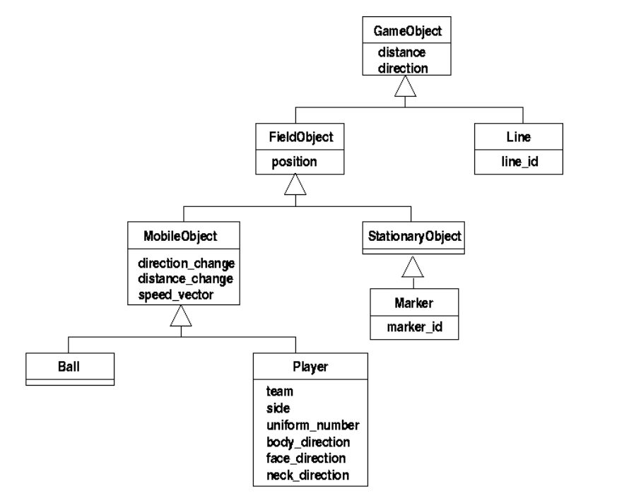

Then we installed and compiled the monitor, The Soccer Monitor is a visualisation tool that allows people to see what is happening within the server during a game. If the monitor is not used, the project will be displayed in the form of instructions in the terminal of Linux.

Team code, we use wrighteaglebase, The team code will send data signals to the server in real time to control how the server's player objects react.

Player Command Protocol:
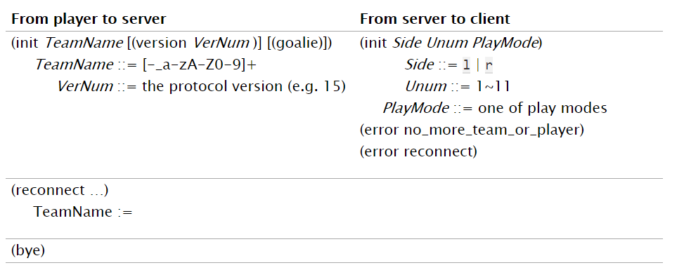
The control model in the code is the code that simulates the physical effect:

Aural Sensor Model
Vision Sensor Model
Body Sensor Model
Movement Models
Movement Noise Model
Collision Model
Catch Model
Dash Model

(atx,aty)=Power×power_rate×(cos(θt),sin(θt))

θtball=θtkicker+Direction

for example, These two codes control the direction of the player's kick and kick respectively.
And The goalie is the only player with the ability to catch a ball.
This is Catchable area of the goalie when doing a catch:
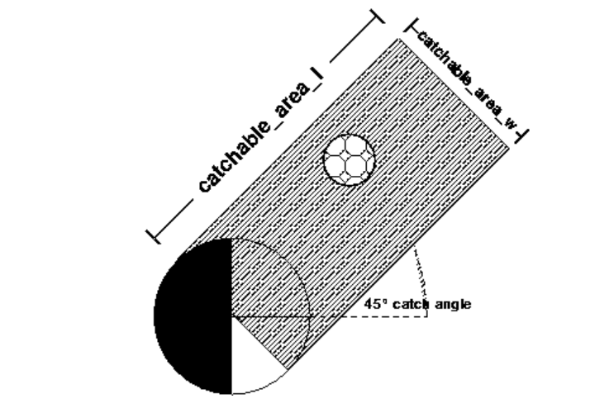

Designers need to write various aspects of physical simulation code to achieve a complete game, After realizing the physical effect, we must write the whole team and make it in different situations. A team's AI system. These mission plans will be tried at a later time.

The important part of this project is to understand the implementation of physical code and write own team to control AI.

Bilder zum Projekt:

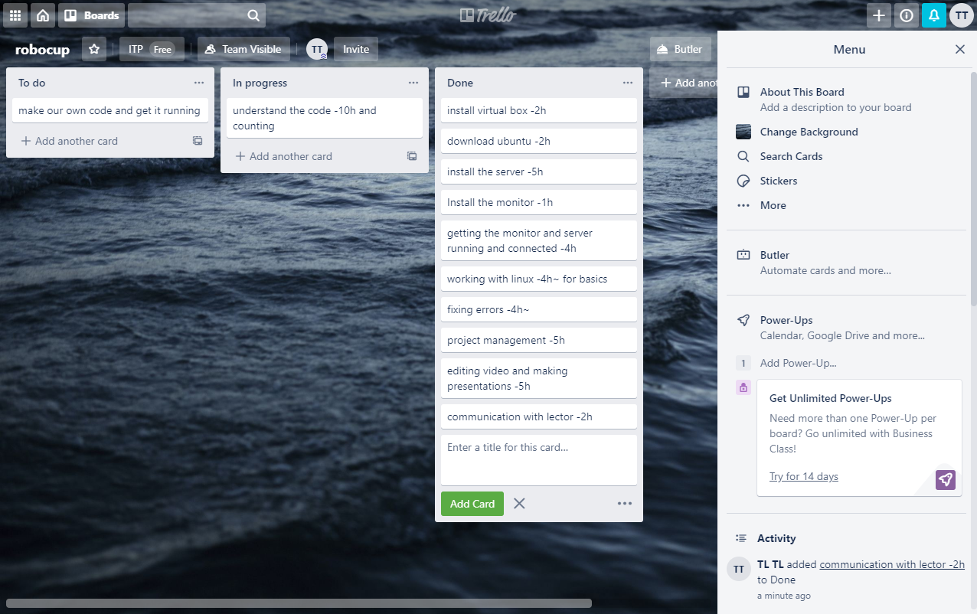
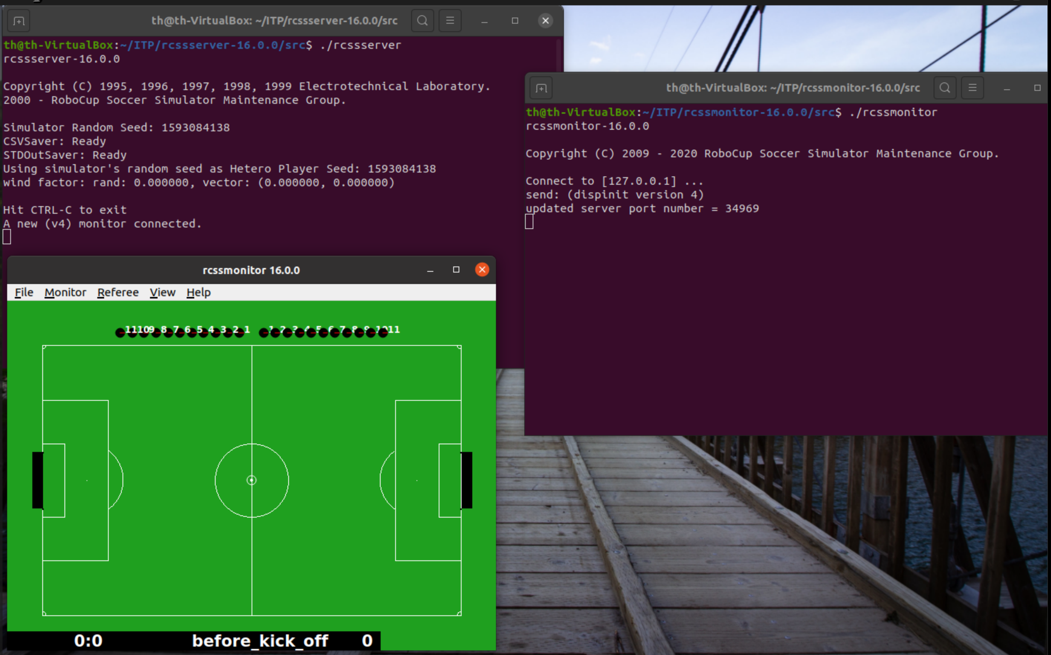

Erwähnenswerte Ereignisse bei der Durchführung:

The project is divided into two parts,

The first part is to learn and use Linux system proficiently, Learn the system environment required to load and compile simulations, Understand the method of simulation system operation and Ways to communicate with various objects and programs, Understand the function and operation method of physical simulation code.

The second part is to try to modify the physical simulation code to achieve the physical effect we want to complete, Design the team's game tactics and write the team's AI system.

Projektrahmen:
Studiengang: Bachelor Informatik
Semester: 2
Jahr: 2020
Lehrveranstaltung: IT-Projektarbeit
Status: in progress

Projektaufwand:
Stunden gesamt: 230

Auftraggeber / Firmenbeteiligungen:
Auftraggeber:

Keiner.

Projekttypus:

Eigenes Projekt.

Projektdaten:

Link: https://github.com/rcsoccersim
https://github.com/wrighteagle2d/wrighteaglebase
https://github.com/rcsoccersim/rcssserver/releases
https://github.com/rcsoccersim/rcssmonitor/releases

Projektumfeld:
The project is developed and running on linux ubuntu *64, The program is written in C++.

